Race Ceremony

DESCRIPTION:
Remember a classic racing podium has three platforms for first, second and third place. First place is the highest and second place is higher than third. Also notice that platforms are arranged as 2nd - 1st - 3rd.
The organizers want a podium that satisfies:
- The first place platform has the minimum height possible
- The second place platform has the closest height to first place
- All platforms have heights greater than zero.

Task
Given the numbers of blocks available, return an array / tuple or another data structure depending on the language (refer sample tests) with the heights of 2nd, 1st, 3rd places platforms.

SOLUTION:
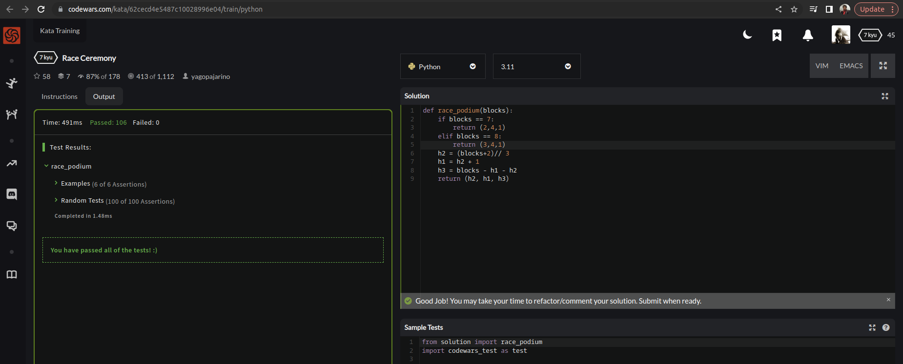

EXPLANATION:
This function calculates the positions for the top three finishers in a race based on the number of blocks they had to run. The function first checks for two special cases where the positions are predetermined, and then calculates the positions for all other cases.
The calculation is done by dividing the number of blocks by 3 and rounding up to get the height of the second place block pile (h2). The height of the first place block pile (h1) is then one more than h2, and the height of the third place block pile (h3) is the difference between the total number of blocks and the sum of h1 and h2.
The function returns a tuple containing the heights of the block piles for the first, second, and third place finishers in that order.

